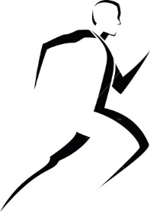
Freeport Area Middle School
6th Grade Physical Education
Mr. Lowry

Contact Information: John Lowry
lowry@freeport.k12.pa.us
724-295-9020 ext.
Website: https://www.freeport.k12.pa.us/olc/127
Six Day Rotation
Sixth grade students will have physical education on all Day 1s of our six day rotation cycle.

General Rules

Report to locker room at beginning of period to change into PE clothes
Be on time for class and prepared to participate
Follow directions of the teacher and actively participate in all activities
Respect others
Observe all safety rules
No gum or jewelry

*Please note that all other school rules, as described in the student handbook, must be followed.

Appropriate Dress
Students must wear:
Athletic shoes (No street shoes or hiking boots)
PE shorts (No cut-offs, boxer shorts or yoga gear)
T-shirt (No alcohol, tobacco ads or any other inappropriate slogans)

PE clothes should be clean, neat and washed regularly. Clothes worn to school MAY NOT be used for physical education class that day.

Grading
The physical education grade is based on the following categories: attendance, punctuality, dress, conduct, cooperation, participation, and performance. A total of ten points can be earned each class period. Points will be deducted for the following reasons:

Late for roll call (-1 pt)
Missing one item of appropriate PE attire (shoes, shirt, or shorts) (-1 pt per item)
Missing more than one item of appropriate PE attire (-5 pts) **
Lack of participation and poor performance (-6 pts)
Non-participation/missed classes (-10 pts)

At the end of the nine weeks, point deductions will be totaled. In addition to the daily grade, teachers may also use written evaluation and or skill tests as part of the student evaluation.

